Y11 Combined Chemistry 1
PPE 2 - Higher
For each topic, there are questions in the Revision Guide that will help you choose what to revise. The page numbers you need are listed below.
Topic | Questions  Page Title |  | Support  Pages
Development of the atomic model | 111 | Electronic Structure… | 103-106
Group 7 | 111 | Groups of the Periodic Table | 107-110
Ionic bonding | 122 | Ions and Ionic Compounds | 112-114
Graphite | 122 | Covalent substances | 115-118
Graphenes and fullerenes | 122 | Covalent substances | 115-118
Concentrations of solutions | 137 | Concentrations of Solutions | 128
Use of amount of substance | 137 | Mole and Equations | 123-127
Strong and weak acids | 137 | Acids and their Reactions | 129-131
RPA – Making a salt | 137 | Acids and their Reactions | 131
RPA – Energy Transfer | 141 | Exothermic and Endothermic Reactions | 139

Exam Practice
The following pages contain past exam questions that should attempt.
The grade for each question is indicated by:
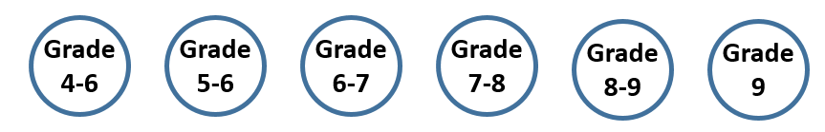


Remember: to get Grade 7, 8 or 9 you still have to be able to answer the 4-5 questions!

Models of the Atom
Q1.
Figure 1 shows two models of the atom.
Figure 1
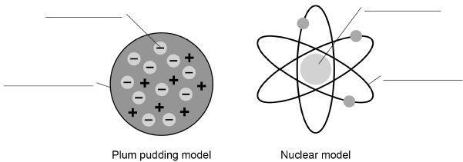
(a) Write the labels on Figure 1
Choose the answers from the box.

atom | electron | nucleus
neutron | orbit | proton
(4)
(b) Explain why the total positive charge in every atom of an element is always the same.
___________________________________________________________________
___________________________________________________________________
___________________________________________________________________
___________________________________________________________________
(2)
(c) The results from the alpha particle scattering experiment led to the nuclear model.
Alpha particles were fired at a thin film of gold at a speed of 7% of the speed of light.
Determine the speed of the alpha particles.
Speed of light = 300 000 000 m/s
___________________________________________________________________
___________________________________________________________________
Speed = _____________________ m/s
(2)
(d) Figure 2 shows two atoms represented as solid spheres.
Figure 2
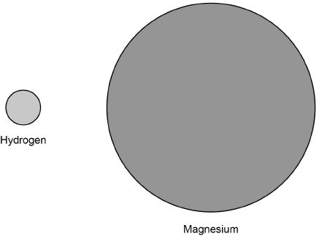
A hydrogen atom has a radius of 2.5 × 10⁻¹¹ m
Determine the radius of a magnesium atom.
Use measurements from Figure 2
___________________________________________________________________
___________________________________________________________________
Radius = _____________________ m
(2)
(Total 10 marks)
Group 7, The Halogens
Q2.
This question is about the halogens.
(a) Write the state symbol for chlorine at room temperature.
Cl₂ (______)
(1)
(b) The diagram below represents one molecule of fluorine.
Complete the dot and cross diagram on the diagram above.
You should show only the electrons in the outer shells.
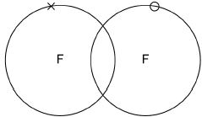
(2)
(c) A fluorine atom can be represented as 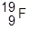
What is the total number of electrons in a fluorine molecule (F₂)?
Tick one box.

9 |  | 14 |  | 18 |  | 38
(1)
(d) Aluminium reacts with bromine to produce aluminium bromide.
Complete the balanced chemical equation for this reaction.
______Al + ______Br₂ ⟶ 2__________
(2)
(e) When chlorine reacts with potassium bromide, chlorine displaces bromine.
Cl₂ + 2 KBr ⟶ Br₂ + 2 KCl
Explain why chlorine is more reactive than bromine.
___________________________________________________________________
___________________________________________________________________
___________________________________________________________________
___________________________________________________________________
___________________________________________________________________
___________________________________________________________________
___________________________________________________________________
___________________________________________________________________
___________________________________________________________________
___________________________________________________________________
___________________________________________________________________
___________________________________________________________________
___________________________________________________________________
(3)
(Total 9 marks)
Ionic Bonding
Q3.
This question is about fluorine.
(a) Figure 1 shows the arrangement of electrons in a fluorine atom.
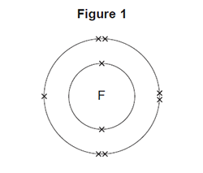
(i) In which group of the periodic table is fluorine?
Group _______________________________
(1)
(ii) Complete the table below to show the particles in an atom and their relative masses.

Name of particle | Relative mass
Proton
Neutron | 1
 | Very small
(2)
(iii) Use the correct answer from the box to complete the sentence.

alkalis | alloys | isotopes
Atoms of fluorine with different numbers of neutrons are
called ________________ .
(1)
(b) Sodium reacts with fluorine to produce sodium fluoride.
(i) Complete the word equation for this reaction.
sodium + ___________________ → ____________________
(1)
(ii) Complete the sentence.
Substances in which atoms of two or more different elements are chemically
combined are called _____________________ .
(1)
(iii) The relative formula mass (M_{r}) of sodium fluoride is 42.
Use the correct answer from the box to complete the sentence.

ion | mole | molecule
The relative formula mass (M_{r}), in grams, of sodium fluoride is one
_______________ of the substance.
(1)
(iv) Figure 2 shows what happens to the electrons in the outer shells when a sodium atom reacts with a fluorine atom.
The dots (•) and crosses (×) represent electrons.
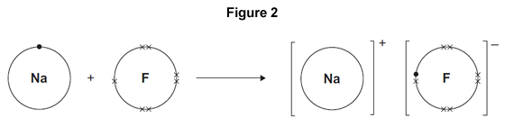
Use Figure 2 to help you answer this question.
Describe, as fully as you can, what happens when sodium reacts with fluorine to produce sodium fluoride.
______________________________________________________________
______________________________________________________________
______________________________________________________________
______________________________________________________________
______________________________________________________________
______________________________________________________________
______________________________________________________________
______________________________________________________________
(4)
(v) Sodium fluoride is an ionic substance.
What are two properties of ionic substances?

Tick (✔) two boxes.
Dissolve in water | 
Gas at room temperature
High melting point
Low boiling point
(2)
(Total 13 marks)
Graphite and Nanotubes
Q4.
Carbon atoms are used to make nanotubes.
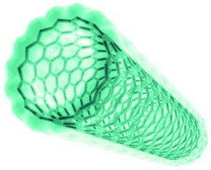
© Denis Nikolenko/Hemera/Thinkstock
Carbon atoms in a nanotube are bonded like a single layer of graphite.
The figure below shows the structure of a single layer of graphite.
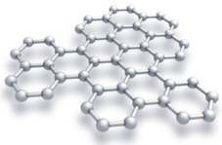
© Evgeny Sergeev/iStock/Thinkstock
(a) Suggest why carbon nanotubes are used as lubricants.
___________________________________________________________________
___________________________________________________________________
___________________________________________________________________
___________________________________________________________________
(2)
(b) Explain why graphite can conduct electricity.
___________________________________________________________________
___________________________________________________________________
___________________________________________________________________
___________________________________________________________________
(2)
(Total 4 marks)
Graphene
Q5.
Scientists have recently developed a method to produce large sheets of a substance called graphene.
Graphene is made from carbon and is a single layer of graphite just one atom thick.

The properties of graphene include: | 
• it conducts electricity
• it is transparent since it is only one atom thick
• it is strong and durable.
These properties make it suitable to overlay a monitor screen to make it a touchscreen.
The photograph below shows the structure of graphene.
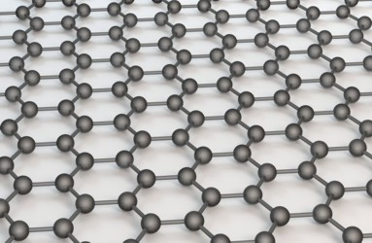
Photographs supplied by iStockphoto/Thinkstock
Use your knowledge of the bonding in graphite and the photograph of the structure to help you to explain, as fully as you can:
(a) (i) why graphene is strong;
______________________________________________________________
______________________________________________________________
______________________________________________________________
______________________________________________________________
______________________________________________________________
______________________________________________________________
(3)
(ii) why graphene conducts electricity.
______________________________________________________________
______________________________________________________________
______________________________________________________________
______________________________________________________________
______________________________________________________________
(2)
(b) Suggest why a sheet of graphite which has a large number of carbon layers would not be suitable for the touchscreen.
___________________________________________________________________
___________________________________________________________________
(1)
(Total 6 marks)
Concentration
Q6.
Figure 1 shows a reactor used to produce titanium from titanium(IV) chloride.
Figure 1
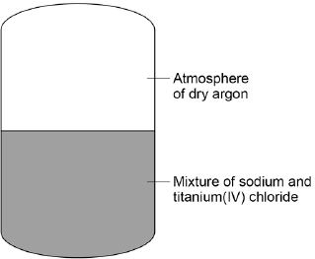
The chemical equation for the reaction of titanium(IV) chloride with sodium is:
TiCl₄ + 4Na Ti + 4NaCl
titanium(IV) chloride + sodium titanium + sodium chloride

(a) For one reaction:
• 1615 kg titanium(IV) chloride reacted completely with 782 kg sodium
• 1989 kg sodium chloride was produced.
Calculate the mass of titanium produced from this reaction.
___________________________________________________________________
___________________________________________________________________
Mass of titanium = _________________ kg
(1)
(b) The table below shows the solubility of sodium chloride in 100 cm³ of aqueous solution at different temperatures.

Solubility of sodium chloride in g per 100cm³ | Temperature in °C
35.72 | 10
35.89 | 20
36.09 | 30
37.37 | 40
36.69 | 50
37.04 | 60

On Figure 2:
• plot this data on the grid
• draw a line of best fit.
Figure 2
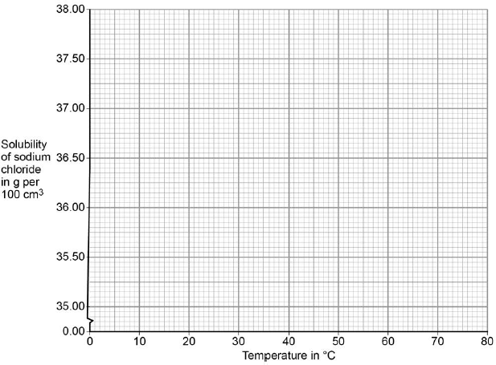
(3)
(c) The product sodium chloride is dissolved in water to separate it from titanium.
At 30 °C the solubility of sodium chloride is 36 kg per 100 dm³.
Calculate the minimum volume of water in dm³, at 30 °C, needed to dissolve 1989 kg sodium chloride.
___________________________________________________________________
___________________________________________________________________
___________________________________________________________________
___________________________________________________________________
Volume of water = ____________________ dm³
(2)
(d) Calculate the percentage by mass of titanium in titanium(IV) chloride (TiCl₄).
Give your answer to 3 significant figures.
Relative atomic masses (A_{r}): Cl = 35.5; Ti = 48
___________________________________________________________________
___________________________________________________________________
___________________________________________________________________
Percentage of titanium by mass = _______________ %
(3)
(e) Suggest why the reaction is done in an atmosphere of dry argon instead of air containing water vapour.
___________________________________________________________________
___________________________________________________________________
___________________________________________________________________
___________________________________________________________________
___________________________________________________________________
___________________________________________________________________
(3)
(f) Explain why titanium conducts electricity.
___________________________________________________________________
___________________________________________________________________
___________________________________________________________________
___________________________________________________________________
___________________________________________________________________
___________________________________________________________________
(3)
(Total 15 marks)
Amount of Substance (Moles)
Q7.
This question is about iron.
Iron reacts with dilute hydrochloric acid to produce iron chloride solution and one other product.
(a) Name the other product.
___________________________________________________________________
(1)
(b) Suggest how any unreacted iron can be separated from the mixture.
___________________________________________________________________
___________________________________________________________________
(1)
Magnesium reacts with iron chloride solution.
3 Mg + 2 FeCl₃ ⟶ 2 Fe + 3 MgCl₂
(c) 0.120 g of magnesium reacts with excess iron chloride solution.
Relative atomic masses (A_{r}): Mg = 24 Fe = 56
Calculate the mass of iron produced, in mg
___________________________________________________________________
___________________________________________________________________
___________________________________________________________________
___________________________________________________________________
___________________________________________________________________
___________________________________________________________________
___________________________________________________________________
___________________________________________________________________
___________________________________________________________________
___________________________________________________________________
Mass of iron = ____________________________ mg
(5)
(d) Explain which species is reduced in the reaction between magnesium and iron chloride.
3 Mg + 2 FeCl₃ ⟶ 2 Fe + 3 MgCl₂
Your answer should include the half equation for the reduction.
___________________________________________________________________
___________________________________________________________________
___________________________________________________________________
___________________________________________________________________
___________________________________________________________________
___________________________________________________________________
___________________________________________________________________
___________________________________________________________________
(3)
(Total 10 marks)
Strong and Weak Acids
Q8.
Hydrogen chloride (HCl) is a gas.
(a) Complete the diagram to show all of the arrangement of the outer shell electrons of the hydrogen and chlorine atoms in hydrogen chloride.
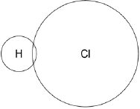
(1)
(b) Hydrochloric acid is a strong acid.
Ethanoic acid is a weak acid.
Describe a reaction that could be used to show the difference between a weak acid and a strong acid.
You should explain why the weak acid and the strong acid give different results.
___________________________________________________________________
___________________________________________________________________
___________________________________________________________________
___________________________________________________________________
___________________________________________________________________
___________________________________________________________________
___________________________________________________________________
___________________________________________________________________
___________________________________________________________________
___________________________________________________________________
(6)
(Total 7 marks)
RPA: Making a Salt
Q9.
A student plans a method to prepare pure crystals of copper sulfate.
The student’s method is:
1. Add one spatula of calcium carbonate to dilute hydrochloric acid in a beaker.
2. When the fizzing stops, heat the solution with a Bunsen burner until all the liquid is gone.
The method contains several errors and does not produce copper sulfate crystals.
Explain the improvements the student should make to the method so that pure crystals of copper sulfate are produced.
_______________________________________________________________________
_______________________________________________________________________
_______________________________________________________________________
_______________________________________________________________________
_______________________________________________________________________
_______________________________________________________________________
_______________________________________________________________________
_______________________________________________________________________
_______________________________________________________________________
_______________________________________________________________________
_______________________________________________________________________
_______________________________________________________________________
_______________________________________________________________________
_______________________________________________________________________
_______________________________________________________________________
_______________________________________________________________________
_______________________________________________________________________
(Total 6 marks)
RPA: Energy Transfers
Q10.
A student investigated the temperature change when zinc reacts with copper sulfate solution.
The student used a different concentration of copper sulfate solution for each experiment.
The student used the apparatus shown below.
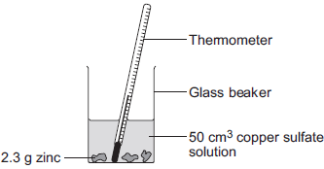
The student:
• measured 50 cm³ copper sulfate solution into a glass beaker
• measured the temperature of the copper sulfate solution
• added 2.3 g zinc
• measured the highest temperature
• repeated the experiment using copper sulfate solution with different concentrations.
The equation for the reaction is:
Zn(s) + CuSO₄(aq) Cu(s) + ZnSO₄(aq)
zinc + copper sulfate solution copper + zinc sulfate solution
(a) The thermometer reading changes during the reaction.
Give one other change the student could see during the reaction.
___________________________________________________________________
___________________________________________________________________
(1)
(b) Suggest one improvement the student could make to the apparatus.
Give a reason why this improves the investigation.
Improvement ________________________________________________________
___________________________________________________________________
Reason ____________________________________________________________
___________________________________________________________________
(2)
(c) In this question you will be assessed on using good English, organising information clearly and using specialist terms where appropriate.
The student’s results are shown in the table below.

Experiment number | Concentration of  copper sulfate  in moles per dm³ | Increase in temperature in °C
1 | 0.1 | 5
2 | 0.2 | 10
3 | 0.3 | 12
4 | 0.4 | 20
5 | 0.5 | 25
6 | 0.6 | 30
7 | 0.7 | 35
8 | 0.8 | 35
9 | 0.9 | 35
10 | 1.0 | 35
Describe and explain the trends shown in the student’s results.
___________________________________________________________________
___________________________________________________________________
___________________________________________________________________
___________________________________________________________________
___________________________________________________________________
___________________________________________________________________
___________________________________________________________________
___________________________________________________________________
___________________________________________________________________
___________________________________________________________________
(6)
(Total 9 marks)

Mark schemes
Q1.
(a) electron
1
atom
1
nucleus
1
orbit
1
(b) positive charge is provided by protons
1
(every atom of the same element contain the) same number of protons
do not accept same number of protons and neutrons
ignore reference to electrons
1
(c) 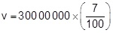
allow any correct method of determining 7% of 300 000 000
1
v = 21 000 000 (m/s)
allow 2.1 × 10⁷ (m/s)
1
an answer of 21 000 000 scores 2 marks
(d) r = 6 × 2.5 × 10⁻¹¹
allow a ratio in the range of 5.7−6.3 or measurements that would give this range, correctly substituted
1
r = 1.5 × 10⁻¹⁰ (m)
allow 1.4 × 10⁻¹⁰ to 1.6 × 10⁻¹⁰
their ratio × 2.5 × 10⁻¹¹ correctly calculated scores 1 mark
1
an answer in the range 1.4 × 10⁻¹⁰ to 1.6 × 10⁻¹⁰ scores 2 marks
[10]
Q2.
(a) g
do not accept upper case (G)
do not accept gas
1
(b)
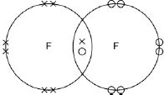
one shared pair anywhere in overlap between two circles or on intersection
1
6 other electrons on each atom
1
allow dots or crosses or mixture for all marks
ignore any inner shell electrons
(c) 18
1
(d) AlBr₃
1
2 Al + 3 Br₂ (⟶ 2 AlBr₂)
1
allow 1 mark for balancing their equation with an incorrect product
(e) chlorine is a smaller atom
or has fewer energy levels
or outer shell closer to nucleus
ignore chlorine has fewer electrons
1
chlorine has less shielding
or
has the greater attraction between the nucleus and the outer shell or incoming electron
1
therefore chlorine can gain an electron (into the outer shell) more easily
1
if no other marks awarded allow 1 mark for correct trend in reactivity in Group 7
do not accept reference to incorrect particles e.g. chloride atom
max 2 if outer shell / level not mentioned
‘it’ refers to chlorine
allow converse reasons for bromine being less reactive
[9]
Q3.
(a) (i) 7 / seven
1
(ii) 1
do not accept –1
1
Electron
1
(iii) isotopes
1
(b) (i) (sodium + ) fluorine → sodium fluoride
1
(ii) compounds
1
(iii) mole
1
(iv) sodium (atom) loses
1
fluorine (atom) gains
1
one electron
1
ions formed
1
allow sodium forms positive (ion) or fluorine forms negative (ion)
allow form ionic bond
allow to gain a full outer shell of electrons
allow forms noble gas structure
max 3 if reference to incorrect particle / bonding
(v) Dissolve in water
1
High melting point
1
[13]
Q4.
(a) nanotubes can slide (over each other)
allow nanotubes can roll (over each other)
1
because no (covalent) bonds between the nanotubes
accept weak forces between the nanotubes or weak intermolecular forces
allow layers for nanotubes throughout
1
(b) delocalised electrons
accept free electrons
1
so (delocalised) electrons can move through the graphite
accept so (delocalised) electrons can carry charge through the graphite
1
[4]
Q5.
(a) (i) ionic / molecules / metallic / (inter)molecular = max 2
because graphene / it has a giant structure / lattice / macromolecular
accept all / every / each atom is bonded to 3 other atoms
1
because graphene / it has covalent bonds / is covalent
1
because in graphene / the bonds are strong or
a lot of energy needed / hard to break the bonds
1
(ii) there are delocalised / free electrons
1
because one (delocalised / free) electron per atom linked to first marking point
accept because three electrons per atom used (in bonding)
accept because one electron per atom not used (in bonding)
1
(b) opaque (owtte)
eg could not see through them
or layers slide
or layers not aligned
ignore thick
1
[6]

Q6.
(a) 408 kg
1
(b) all points correct
± ½ small square
2
allow 1 mark if 5 points correct
best fit line
1
(c) 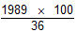
1
5525 dm³
1
(d) relative formula mass of TiCl₄ is 190
1
25.26 %
1
Answer given to 3 significant figures = 25.3 %
1
25.23% with or without working gains 3 marks
(e) argon is unreactive
1
water (vapour) would react with sodium
allow water (vapour) would react with titanium(IV) chloride
1
and air contains oxygen that would react with reactants
allow and air contains oxygen that would react with products
1
(f) (titanium conducts electricity) because electrons in the outer shell of the metal atoms are delocalised
1
and so electrons are free to move
allow the delocalised electrons in the metal carry electrical charge through the metal
1
through the whole structure
1
[15]
Q7.
(a) hydrogen or H₂
allow hydrogen gas
ignore H without the 2 subscript
1
(b) filtration / filter
allow magnet or decant
ignore heating
1
(c) 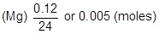
mark is for ÷ by 24
1
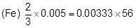
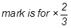
1
(mass Fe) = 0.00333 × 56
mark is for × 56
1
= 0.1866 (g)
1
= 187 (mg)
1
an answer of 280 (mg) scores 4 marks
an answer of 0.280 scores 3 marks (no ratio from equation)
184 scores 0 [= (3 × 24) + (2 × 56)]
OR
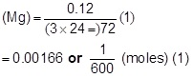
(mass of Fe) = 0.00166
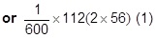
= 0.1866 (g) (1)
187 (mg) (1)
OR
72 g Mg ⟶ 112g Fe (1)
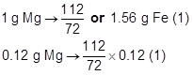
= 0.1866 (g) (1)
= 187 (mg) (1)
an answer of 185−190 (mg) scores 5 marks
an answer of 0.185−0.19 scores 4 marks
(d) Fe³⁺
1
(because) reduction is gain of electrons
allow change in oxidation state / (+)3 to 0
1
Fe³⁺ + 3e⁽⁻⁾ ⟶ Fe
1
[10]
Q8.
(a) bonded pair of electrons and
6 non-bonded electrons on chlorine
1
(b) Level 3 (5–6 marks):
A detailed and coherent explanation of comparative results of a reaction in terms of concentration and ionisation. The response makes logical links between the points
raised and uses sufficient examples to support these links.
Level 2 (3–4 marks):
A description of a reaction with results is given but may miss some details. Links are made but may not be fully articulated and / or precise.
Level 1 (1–2 marks):
Simple statements are made. The response may fail to make logical links between the points raised.
0 marks:
No relevant content
Indicative content
Simple statements / descriptions of a reaction
• correct comparative pH, such as, 0–3 (strong) 4–6 (weak)
• named reaction, such as, with a reactive metal or a named carbonate
• comparative results or observations of the named reaction, such as, faster reaction (strong) or greater volume of gas produced in a given time (strong)
Explanations of different results
• weak acids are only partially ionised in aqueous solution
• strong acids are completely ionised in aqueous solution / greater
concentration of H⁺ ions
• aqueous solutions of acids at the same concentration / same state of division
of metal / powder, same temperature
6
[7]
Q9.
Level 3: Relevant points (reasons / causes) are identified, given in detail and logically linked to form a clear account.
5−6
Level 2: Relevant points (reasons / causes) are identified, and there are attempts at logical linking. The resulting account is not fully clear.
3−4
Level 1: Points are identified and stated simply, but their relevance is not clear and there is no attempt at logical linking.
1−2
No relevant content
0
Indicative content
• uses sulfuric acid not hydrochloric acid
or sulfuric acid needed
• uses copper carbonate / oxide not calcium carbonate
or copper carbonate / oxide needed
• add solid until solid remains or is in excess or no more reacts / dissolves
so that most / all of the acid reacts
• filter
to remove excess or unreacted carbonate / oxide / solid
• heat gently or partially evaporate or leave
until crystals appear or to crystallise
for level 3 the correct chemicals must have been selected
[6]
Q10.
(a) any one from:
• solution becomes colourless or colour fades
• zinc becomes bronze / copper coloured
allow copper (forms) or a solid (forms)
• zinc gets smaller
allow zinc dissolves
• bubbles or fizzing.
ignore precipitate
1
(b) improvement:
use a plastic / polystyrene cup or add a lid
accept use lagging / insulation
1
reason - must be linked
reduce / stop heat loss
OR
improvement:
use a digital thermometer
allow use a data logger
reason - must be linked
more accurate or easy to read or stores data
allow more precise or more sensitive
ignore more reliable
ignore improvements to method, eg take more readings
1
(c) Marks awarded for this answer will be determined by the Quality of Written Communication (QWC) as well as the standard of the scientific response. Examiners should also refer to the information in the Marking Guidance and apply a ‘best–fit’ approach to the marking.
0 marks
No relevant content
Level 1 (1−2 marks)
There is a statement about the results.
Level 2 (3−4 marks)
There are statements about the results. These statements may be linked or may include data.
Level 3 (5−6 marks)
There are statements about the results with at least one link and an attempt at an explanation.
Examples of chemistry points made in the response:
Description:
Statements
Concentration of copper sulfate increases
Temperature change increases
There is an anomalous result
The temperature change levels off
Reaction is exothermic
Linked Statements
Temperature change increases as concentration of copper sulfate increases
The temperature change increases, and then remains constant
After experiment 7 the temperature change remains constant
Statements including data
The trend changes at experiment 7
Experiment 3 is anomalous
Attempted Explanation
Temperature change increases because rate increases
Temperature change levels off because the reaction is complete
Explanation
As more copper sulfate reacts, more heat energy is given off
Once copper sulfate is in excess, no further heat energy produced
6
[9]

